May 6, 2024

The Honorable Pete Buttigieg
Secretary of Transportation
U.S. Department of Transportation
1200 New Jersey Avenue, SE
Washington, DC 20590
Dear Secretary Buttigieg,

I am writing to express MCOG’s strong support of the Maine Department of Transportation’s Searsport Offshore Wind Port Project 2024 Port Infrastructure Development Program (PIDP) Grant application. The PIDP grant funds would support the pre-construction activities through Final Design accelerating the development of the Project.

The construction of the port at Sears Island will unlock the immense energy potential in the Gulf of Maine with the development and deployment of Floating Offshore Wind (FOSW). Consistent with the goals of the Biden Administration to deploy 15 Gigawatts (GW) of FOSW by 2035, construction of the port will also meet Maine’s goal outlined in the Maine Energy Plan: Pathway to 2040 identifies the need for at least 3 GW of offshore wind with the goal of 100 percent clean energy by 2040. As offshore wind advances in the Gulf of Maine, Maine can leverage its existing deepwater port infrastructure to create additional economic opportunities for the state.

MCOG’s fully support Maine’s application for these federal funds which will be critical to advancing efforts on this project in the immediate future and unlocking additional investments in clean energy generation and long-term local economic development opportunities. With the construction of the port, we are confident Maine’s leadership will contribute to growing domestic expertise and supply chain capabilities to support a robust offshore wind industry in the United States.

In summary, we are in full support of this project and respectfully request your strong consideration of this application.

Sincerely,
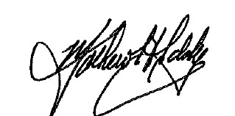
Mathew Eddy
Executive Director

